**Solution-1**

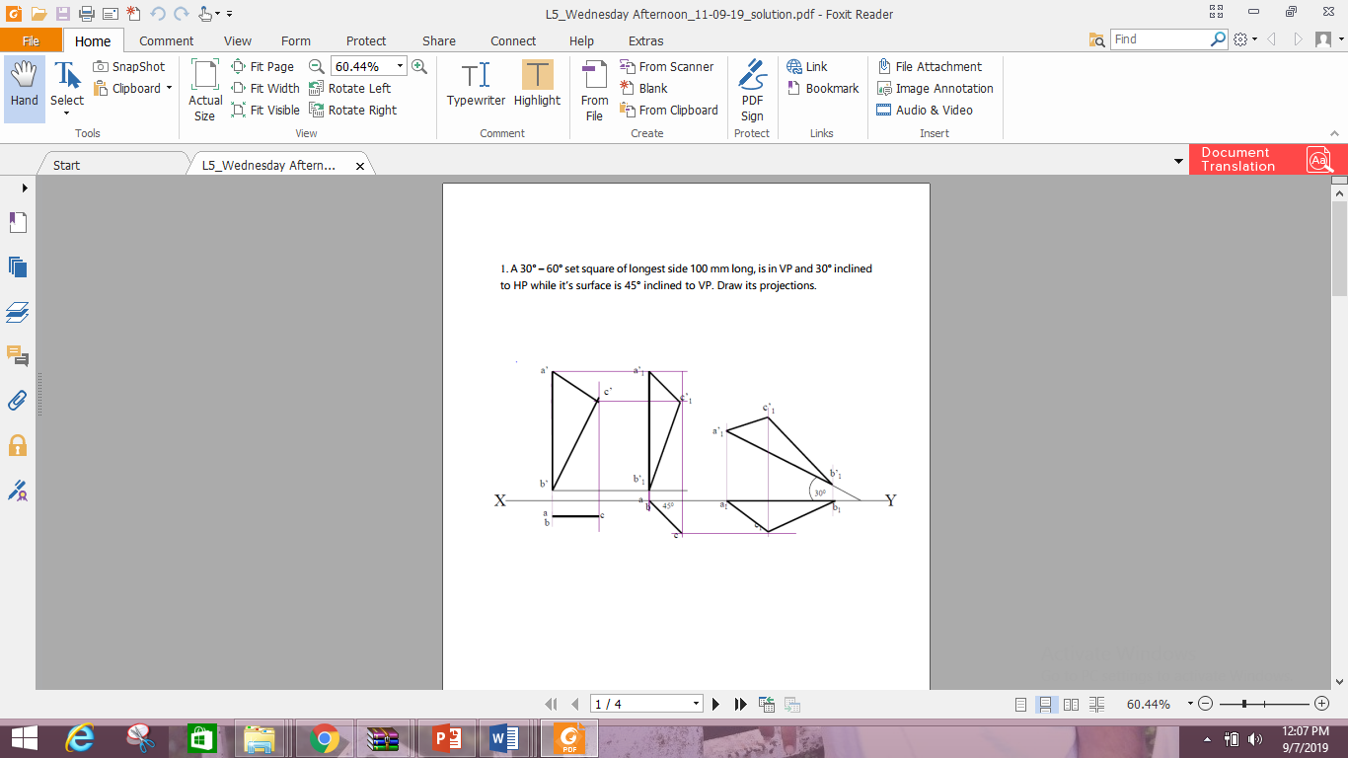

**Solution-2**

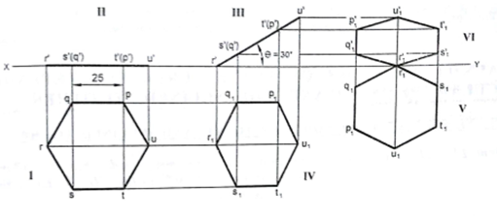

**Solution-3**

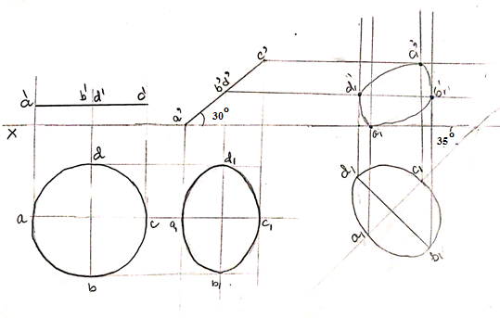

**Solution-4**

Initially, side AD can make any angle in TV but can not remail perpendicular with XY

